**Tuần 9 (01/10-07/10/2021) -TIẾT 1**

**MID- TERM TEST’S CORRECTION**

**THE END**

**Tuần 9 (01/10-07/10/2021)- TIẾT 2**

**UNIT 5: WORK AND PLAY**

**A. IN CLASS/ 51**

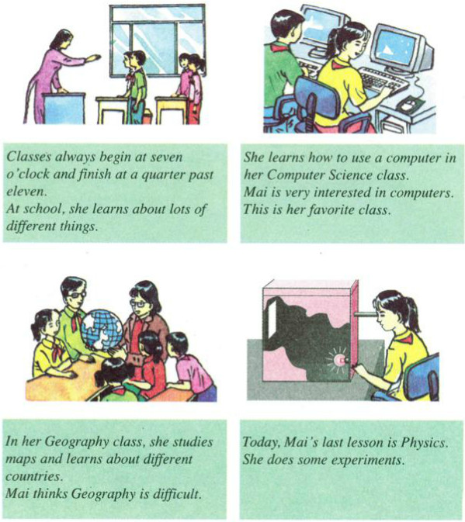1. Mai is a student at Quang Trung School. She is in grade 7. She goes to school at six days a week, from Monday to Saturday.

**VOCABULARY:**

1. begin (v.) /bɪˈgɪn/ = start (v.): bắt đầu

2. difficult (a.): khó khăn

🡪 difficulty (n.): sự khó khăn

2. be interested in = love: thích, yêu thích

3. map (n.) /mæp/: bản đồ

4. country (n(số ít)) /ˈkʌntrɪ/🡪 countries (n (số nhiều)): đất nước

5. lesson (n.) /ˈlesən/: bài học

6. experiment (n.) /ikˈsperɪmənt/: thí nghiệm

**2/52** **Read then answer the questions.**

Ba goes to Quang Trung School. He is in class 7 A and he **enjoys** school very much. His favorite subject is **Electronics**. In this class, he learns to **repair** **household appliances**. Now Ba can help his mother and father at home. He can **fix** the **lights**, the washing machine, and the refrigerator. He **is good at** fixing things.

In his free time, Ba learns to play the guitar. He also goes to his art club after school. His **drawing**s are very good. His teacher says, "Ba, you'll be a **famous artist** one day."

**VOCABUALRY**

1. enjoy (v.) /ɪnˈdʒɔɪn/= love (v.): thích, yêu thích

2. Electronics (n.) /ɪlekˈtrɒnɪks/: môn Điện

3. repair (v.) /rɪˈpeər/: sửa chữa

4. household (n.) /ˈhaʊshəʊld/: hộ gia đình

5. appliance /əˈplaɪəns/ (n): thiết bị

6. fix / fɪks/ (v): sửa chữa

7. light (n.) /laɪt/: bóng đèn

8. be good at: giỏi về

🡪 be good at+ V.ing: giỏi về làm cái gì đó

9. drawing /ˈdrɔɪŋ/ (n): tranh vẽ

10. famous /ˈfeɪməs/ (adj): nổi tiếng

11. artist (n.) /ˈɑ:tɪst/: nghệ sĩ

🡪 art (n.) /ˈɑ:t/: nghệ thuật

**5/ 54 Read**

At school, we **study** many things. In Literature, we learn about books and write **essays**. In History, we study **past** and present events in Viet Nam and around the world. In Geography, we study different countries and their people. In Physics, we learn about how things work. In the **Language** class, we study English. We study many other things as well, such as Music, Sports, and Art. We enjoy all of our classes.

**VOCABULARY**

1. study (v.) /ˈst ʌdi/: học tập

🡪 student (n.): học sinh

2. essay (n.) /eˈseɪ/: bài văn

3. past (a.) /pɑ:st/: quá khứ # present /ˈprɛzənt/ (adj): hiện tại

4. language (n.) /ˈl æ ηgwidʒ/: ngôn ngữ

EXERCISE

**Task 6. Match each subject to the correct items.**

(Ghép mỗi môn học với từ đúng cho mỗi môn)

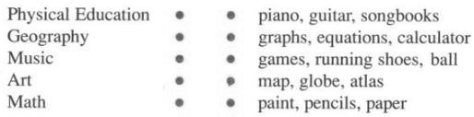

- graph (n.) /gr ɑ:f/: biểu đồ

- equation /ɪˈkweɪʒən/ (n): công thức

- calculator /ˈkælkjuleɪtər/ (n.): máy tính

- globe /gloʊb/ (n): quả địa cầu

- atlas /ˈætləs/ (n): tập bản đồ

**Tuần 10 (08-14/11/2021)**- **TIẾT 1**

**UNIT 5: WORK AND PLAY**

**B. IT’S TIME FOR RECESS.**

**1/56**

At twenty-five past nine, the **bell** rings and all the students go into the yard. It's time for **recess**. They are all happy and **excited**. They meet their friends and have some fun. Many are talking about the last class, or last night’s movie. Some are eating and drinking **as well as** **chat**ting. Some students are playing games like **blindman's bluff** or catch. Some boys are playing **marbles** and some girls are skipping rope. But the most popular **activity** is talking. The yard is very noisy until the bell rings. Then everyone goes **indoors** and classes begin again.

**VOCABULARY**

1. bell /bɛl/ (n): cái chuông

2. recess (n.): giờ ra chơi

3. excited (a.) /ɪksaɪtɪd/: cảm thấy phấn khích

🡪 exciting (a.)/ɪksaɪtɪη/: phấn khích

4. as well as: cũng như

5. chat /ˈ tʃæt/ (v): tán gẫu

6. blindman's bluff /ˈblaɪndˌmænz ˈbʌf/ (n): trò bị mắt bắt dê

7. marbles /ˈmɑrbəlz/ (n): trò bắn bi

8. activity (n.): hoạt động

🡪 act (v.): hành động

9. indoors /ɪnˈdɔrz/ (adv): trong nhà

**EXERCISE :**  use the words in the passage and write nex to the letter for the picture below

(dùng các từ trong bài đọc và viết cạnh các chữ cái trong bức tranh sau)

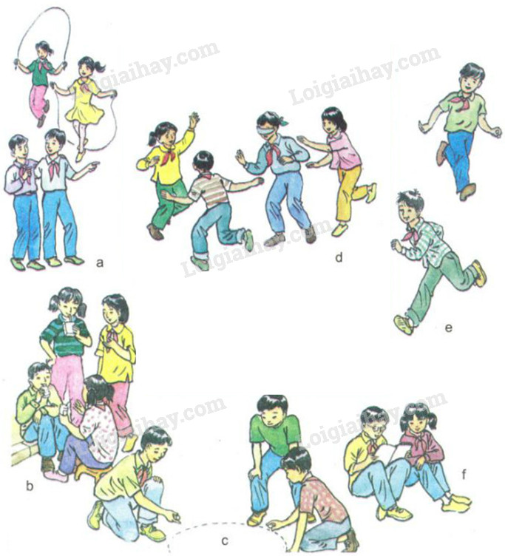

**3/57**

Hoa has a letter from her American **pen pal**. Tim. Tim goes to a **junior high school** in California. He is 13 years old. He is the same age as Hoa and her friends. He tells her about American students.

American students **take part in** different activities at recess. The **energetic** students often play basketball, but they never have time to play a whole game. They just **practice** **scoring** goals. That is called “shooting some hoops"

Many of the students listen to music. They usually have **portable** CD players with small earphones. Sometimes they read or study at the same time.

Some of the children, mainly boys, **swap** baseball cards. These pictures of baseball players come in packets of candy. They swap cards with their friends, so they can get the ones they want.

Eating and talking with friends are the most common ways of **relaxing** at recess. These activities are the same all over the world.

VOCABULARY:

1. pen pal /penpæl/ (n): bạn qua thư

2. junior high school= secondary high school

Ex: Nguyen Duc Canh Junior High School= Nguyen Duc Canh Sencondary School

3. energetic /ˌɛnərˈdʒɛtɪk/ (n): hiếu động, nhiều năng lượng

4. practice (v.): thực tập

5. score /skɔːr/ (v): ghi bàn (thể thao)

6. portable /ˈpɔrtəbəl/ (adj): có thể xách tay

7. swap /swɑːp/ (v): trao đổi

8. relax /rɪˈlæks/ (v): thư giãn

EXERCISE: a) Hoa’s pen pal Tim goes to...

A. Hoa's school. B. a school in Viet Nam.

C. an American school. D. a senior high school.

b) "...they never have time to play a whole game." This means recess is ...

A. short. B. boring. C. energetic. D. long.

c) baseball cards are popular with ...

A. everyone. B. only girls. C. only boys. D. mostly boys.

d) Eating and talking with friends are popular activities ...

A. in America. B. in Viet Nam. C. in a few countries. D. worldwide.

**Tuần 10 (08-14/11/2021)- TIẾT 2**

**UNIT 5- LANGUAGE FOCUS**

**I. Put the words in the brackets in the correct form**

* 1. Mai is very _____________ in computers. (interest)
  2. She thinks Geography is _____________. (difficulty)
  3. The yard is very _____________ at recess (noise)
  4. The students are _____________ about the film. (excite)
  5. The most popular _____________ is talking. (act)
  6. The _____________ students often play soccer. (energy)
  7. Recess is really _____________ to me. (excite)
  8. The _____________ students often play soccer and basketball. (energy)
  9. Students take part in different _____________at recess (act)
  10. The school yard is always _____________ at recess. (noise)
  11. Students feel happy and _____________ during recess. (excite)

1. **II. Sentences transformation:**

|  |
| --- |
| **like+ V.ing/N = enjoy+ V.ing/ N = am/ is/are interested in+V.ing = love+ V.ing: thích** |

1. His classmate enjoys playing the guitar.

* His classmate likes

1. My brother is interested in watching TV.

* My brother

1. Does she like cowboy movie?

* Is she ?

1. Do you enjoy listening to music?

* Are you ?

1. He is interested in playing videos games.

* He likes

1. I enjoy listening to music.

* I am

7. Mai is interested in computers

🡪 Mai likes

**THE END**